Types of joins in sql: -

Let’s say we have two sets of data in our relational database: table A and table B, with some sort of relation specified by primary and foreign keys.

Inner join: -The INNER JOIN keyword selects all rows from both the tables as long as the condition satisfies. This keyword will create the result-set by combining all rows from both the tables where the condition satisfies i.e value of the common field will be same.

Left outer join: - This join returns all the rows of the table on the left side of the join and matching rows for the table on the right side of join. The rows for which there is no matching row on right side, the result-set will contain null. LEFT JOIN is also known as LEFT OUTER JOIN

Right join: - RIGHT JOIN is similar to LEFT JOIN. This join returns all the rows of the table on the right side of the join and matching rows for the table on the left side of join. The rows for which there is no matching row on left side, the result-set will contain null. RIGHT JOIN is also known as RIGHT OUTER JOIN.

Full join: -FULL JOIN creates the result-set by combining result of both LEFT JOIN and RIGHT JOIN. The result-set will contain all the rows from both the tables. The rows for which there is no matching, the result-set will contain NULL values

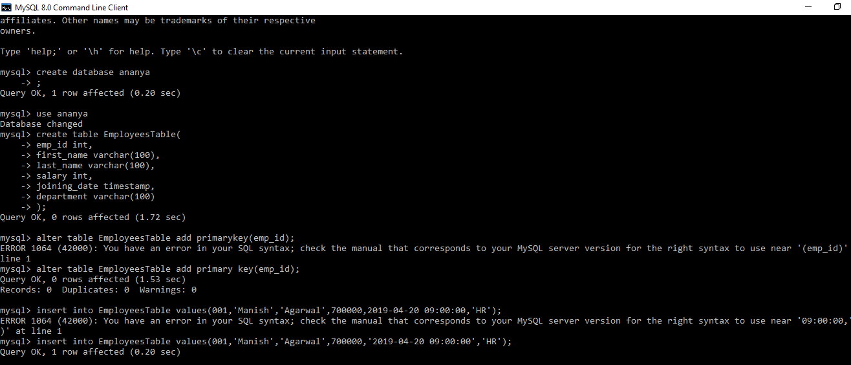

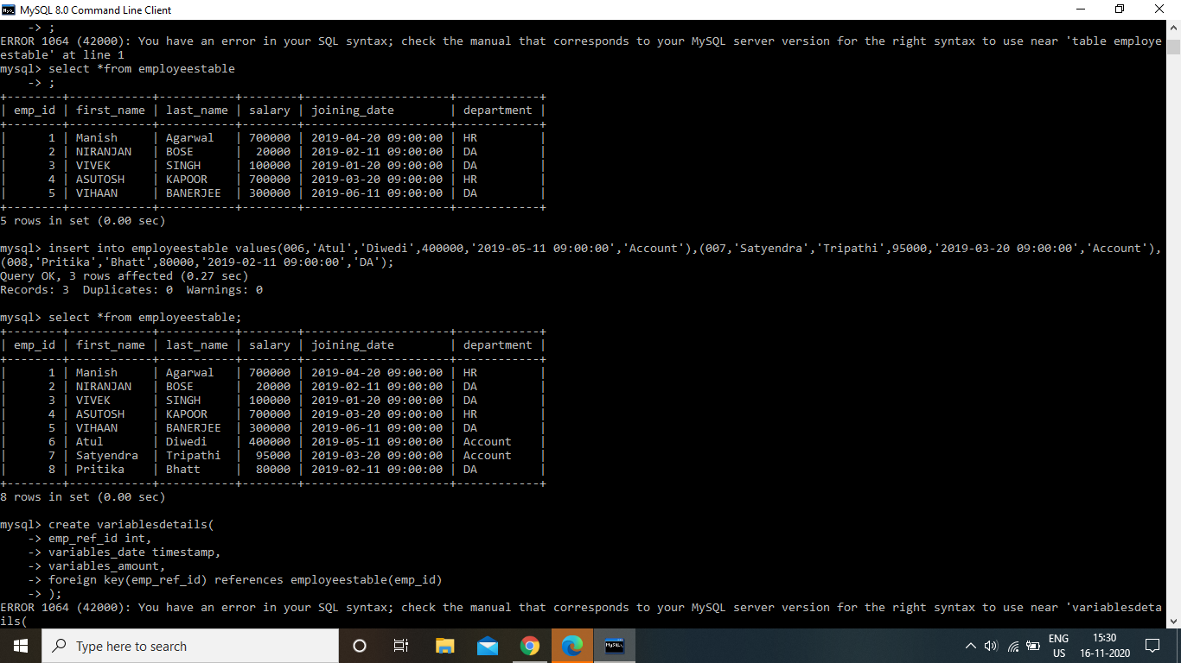

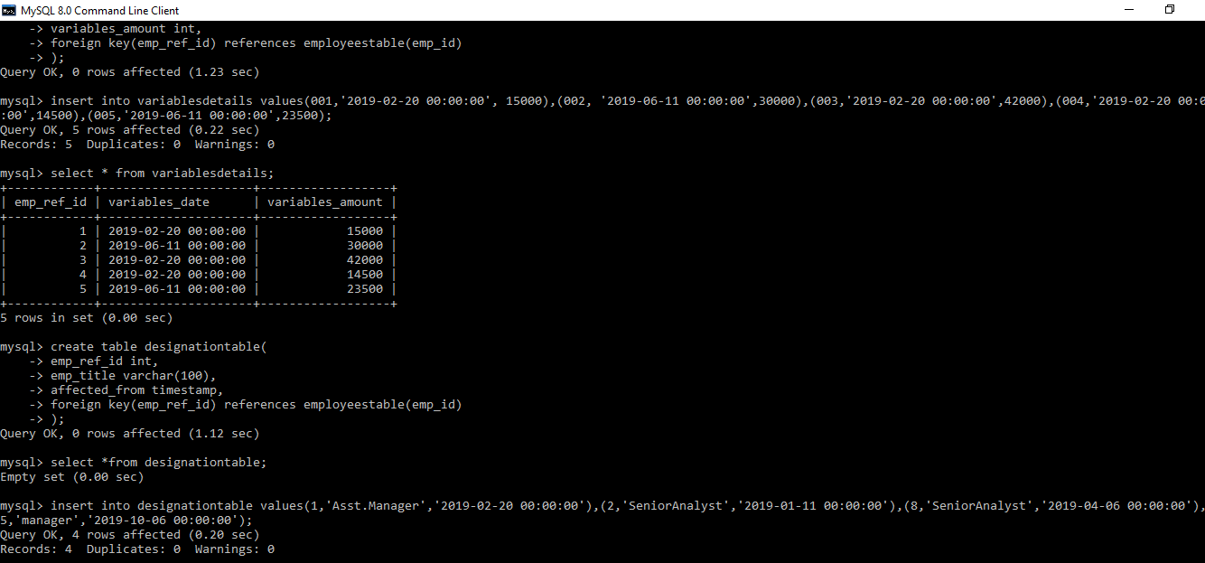

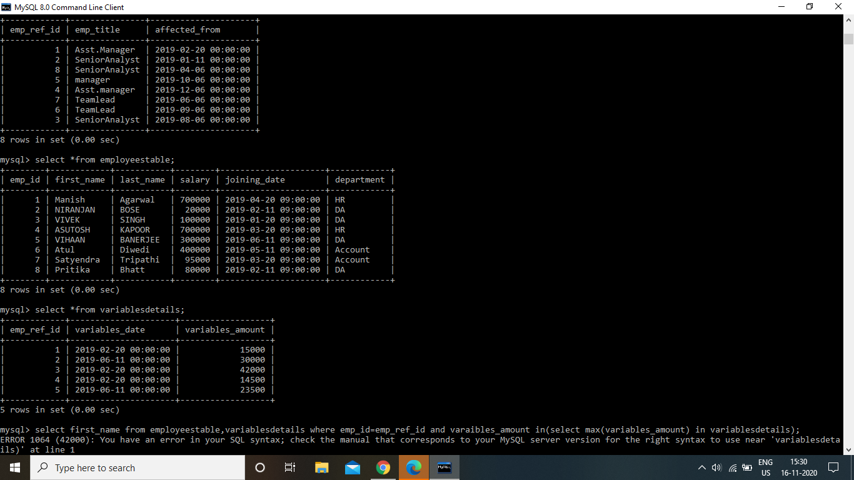

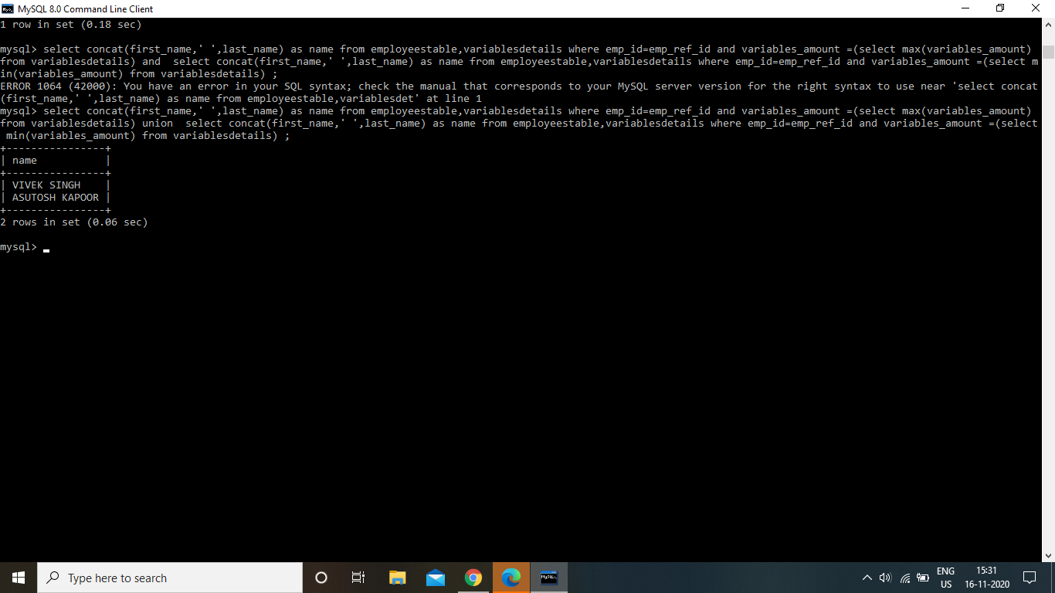

Normalisation: - **It** is a database design technique that reduces data redundancy and eliminates undesirable characteristics like Insertion, Update and Deletion Anomalies. Normalization rules divides larger tables into smaller tables and links them using relationships. The purpose of Normalization in SQL is to eliminate redundant (repetitive) data and ensure data is stored logically.

The inventor of the relational model Edgar Codd proposed the theory of normalization with the introduction of the First Normal Form, and he continued to extend theory with Second and Third Normal Form. Later he joined Raymond F. Boyce to develop the theory of Boyce-Codd Normal Form.

Cursor: -A database cursor is an object that enables traversal over the rows of a result set. It allows you to process individual row returned by a query.

Stored procedure: - A stored procedure is a prepared SQL code that you can save, so the code can be reused over and over again.

So if you have an SQL query that you write over and over again, save it as a stored procedure, and then just call it to execute it.